Standard Operational Procedure:

Dividing a colony in line with swarm control.

Purpose:
This SOP provides detailed instructions on how and when it is best to divide a colony.
Potential Hazards: | Prevention/Action Needed
Getting severely stung | When opening a hive, wear a bee suit, or at minimum, a veil, and gloves, regardless of the task. Ensure your ankles are covered by boots or wellingtons.  It is essential to be gentle with the bees during all manipulations. Avoid rough handling of equipment when removing it to inspect the colony as vibrations upset the bees and cause defensive behaviour.  Always carry anti-histamine cream in your tool kit.  Carry an epi-pen if you are allergic to bee stings.
Falling or tripping on vegetation | Ensure the ground around your colonies is level and clear of vegetation such as briars and nettles.  Carry a mobile phone and if you are working alone tell someone where you are working.
Special Handling & Storage of Supers | Bear in mind that once supers are in place, you are handling a premium food, so cleanliness and hygiene are essential to prevent contamination and spoilage.  Clean your bee suit after every day inspecting bees and have a spare suit if you have several apiaries. Wash all equipment in your tool kit regularly. When transporting full supers, ensure they are placed on a clean surface and immediately stored in a clean, bee-proof room without delay.
First Aid Procedures | Anti-histamine cream.  Anti-histamine tablets.  Epi-pen if allergic to bee stings.
Inspection tool kit & spare equipment-summer inspections | Water mister, Smoker & smoker fuel, lighter, hive tool, frame rest, notebook & pen, spare brood frames, supers, butterfly clip, queen cage, marking tube & queen marking pen and fine scissors (for clipping the queen), an empty box to house the frame the queen is on during longer inspections (nuc box is ideal), a small container (no more than 5L) of washing soda solution (10% by weight), queen excluders, replacement equipment if swapping floors or taking home equipment for cleaning, painting or repair.

Background Information:
Managing bees for swarm control is inextricably linked to colony reproduction. During routine inspections from May until June or early July, the beekeeper provides extra space for the expanding colony. This is also a method of swarm prevention. Regardless of extra space provided, the colony will still probably satisfy the conditions leading to swarming, and the beekeeper will inevitably find queen cells. Early in the season these are likely to be swarm cells and the beekeeper must take immediate action to avoid losing a swarm and therefore losing the honey crop as well as causing a menace to the public. Seven-day inspections along with clipping and marking your queen will also mitigate against losing swarms. Every beekeeper has their preferred method of swarm control, so, by the beginning of May, all necessary extra equipment required for that manipulation, should be brought when doing seven-day inspections.

Planning Ahead:
In order to maintain colony numbers, bee breeders and hobbyist beekeepers alike, must make provision for increasing their stocks to mitigate against colony losses. Part of the preparation for this involves drawing up a plan for the year ahead and assigning stocks to nuc production while others are earmarked for honey production. Some methods of queen rearing allow for both.
If a colony is strong enough, a bee breeder might overwinter selected colonies on double brood. A hobbyist is more likely to over winter bees in single brood boxes. Double brood ensures a good supply of frames of brood, stores and drawn comb to be able to make nucs using materials from that colony alone. It also provides early strong colonies for the artificial rearing of queen cells. Either way, when queen cells are found, the beekeeper has many options in the way a colony is divided, but has no option but to divide it.
Here we present two methods, one for absolute beginners, because it is almost fool proof. The second method is suitable for non-commercial bee breeders who are willing to dismantle a colony on double brood in order to make several nucs. Again, with experience, the options are endless as long as the weather is good and bees are healthy and numerous.

Dividing a Colony [A]- Preface:
During a seven-day inspection, open queen cells are found by a beginner beekeeper, in a strong, healthy colony, housed in a national brood box and two supers. The queen is present but no longer in full lay, as is evident from the ratio of sealed brood to open brood and fresh eggs. The beekeeper wishes to make increase.

Beginners: Artificial Swarm – ‘Pagden Method’
- Remove the roof, supers and queen excluder and place the [parent] hive (with floor and crown board) more than 1 metre to one side.
- Place a new floor and brood box with 9 frames of foundation (or drawn comb if available and disease-free. Insulating dummy boards can be used temporarily if frames are in short supply and/or weather turns cold) and a thin dummy board on the original site and remove 2 frames from the centre to create a gap.
- Inspect the original brood box and find the queen. Place her on a frame with unsealed brood in the gap in the new box. Ensure there are no queen cells on this frame. Take care not to allow the queen to fall off during the transfer. Close up the gap and add the remaining frame at the back of the brood box. Replace the queen excluder, supers, crown board and roof.
Note: if the queen is on the only frame with queen cells or the best queen cells, move the queen to a different frame.
Now turn to the old colony with the eggs, brood and nurse bees and inspect the colony for queen cells. Select ONE nice, large open queen cell and leave in place in the centre of the brood. Mark the frame it is on with a drawing pin and replace it.
- This new queenless state may induce the formation of fresh queen cells. Return in 5 days and break down any new queen cells, which should be regarded as emergency queen cells of inferior quality. Carefully close up the gap and place 2 spare frames at the outer edges. Replace the crown board and roof. There will then be no more larvae present and therefore no more risk of further queen cells.

At this stage the original colony has been artificially swarmed. That is, the old queen and flying bees (in the new box) have been separated from the brood and nurse bees (in the old box). Any flying bees from the old box, will return to the old site and re-join the queen.
- (Optional) After around 6 or 7 days, relocate the parent [brood-containing] hive more than 1 metre to the other side of the new [queen containing] hive. Newly flying foraging bees trying to return to the old hive will drift to the new hive, thus adding to the numbers of the artificial swarm and reducing the likelihood of the box containing brood and queen cells from swarming if an extra queen cell was missed during that inspection.

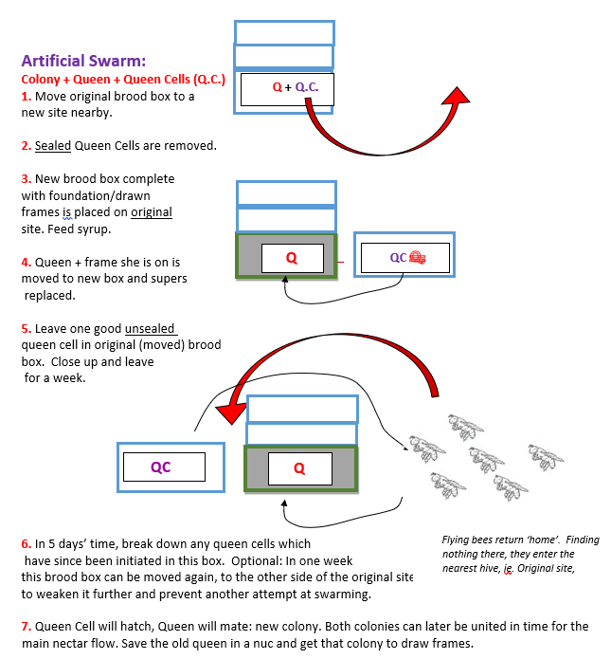

Dividing a strong Colony [B].
Preface: During a seven-day inspection at the beginning of June, a moderate number of open queen cells are found by a beekeeper in their third or fourth year, in a strong, healthy colony with good breeding traits, housed on double brood. The queen is present but no longer in full lay, as is evident from the ratio of sealed brood to open brood and fresh eggs. There is forage available and the beekeeper wishes to make as many nucs as possible with good quality swarm cells from this colony. An out apiary is available.
1. Similar to creating an artificial swarm, move the original colony to one side, about one metre away and place a new floor and brood box with 9 frames of disease-free drawn comb and stores from the original colony (this colony had no supers). Leave a 2-frame gap in the centre.
2. Inspect the original brood box and find the queen. Place her on a frame with unsealed brood in the gap in the new box, ensuring there are no queen cells on this frame.
3. Close the gap and fill the resulting gap at the back of the brood box with a frame of stores and a thin dummy board.
4. You may now have enough frames of brood and stores to make up to seven strong nucs, but the final number of nucs should be based on the number of good quality open queen cells available.
5. Into each nuc box (entrances secured closed) place at minimum two frames, each with a large patch of brood and adhering bees, one having a queen cell, along with two frames of stores. Fill the remaining gap with a thick insulating dummy board.
6. Close up each nuc as it is made, carefully secure the roofs and move to one side for removal to an out apiary that does not have strong colonies on site. Unlike moving colonies late at night or early morning, be ready to move the nucs straight away and open them up as soon as they are in position at the new site.
7. Observe the flying bees entering the original site and take note of how strong this colony is. In good foraging weather, there should be enough stores to last for a number of days after which the foragers should be able to maintain the food supply.
8. Move the new nucs to the out apiary and monitor for stores after a week or so, but do not open for a few weeks after the queens have emerged. It will be obvious from activity at the entrance, whether or not the hive is strong enough and sustaining itself while waiting for the new queen to mate.
9. Bear in mind that these queens are all related, and ultimately arrange them in out apiaries in such a way that minimises cross breeding of drones with new related virgins, the following year. Swap with other breeders or sell them outside your mating area. Another option is to use sealed queen cells from other breeding colonies when making up the nucs.

